**Aarong.com**

**Issue-01:** The name is not specific

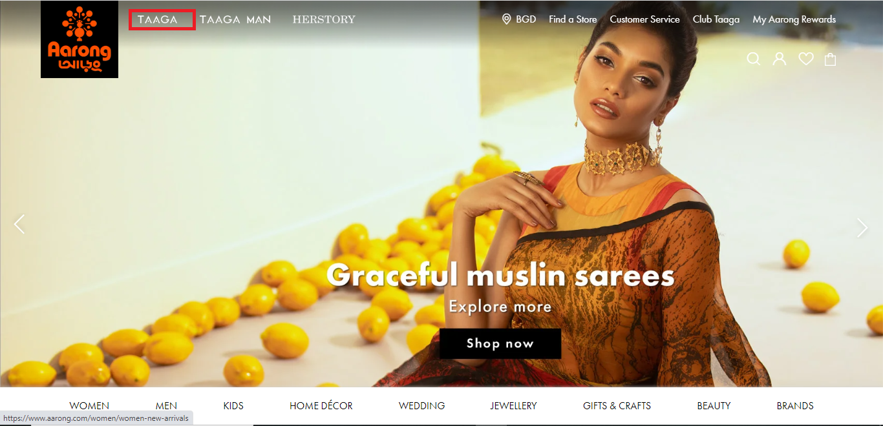

**Description:**

1. Open the site with www.aarong.com
2. Click the TAAGA [ It will open clothing products for women]
3. The bug is found in the name, it should be changed

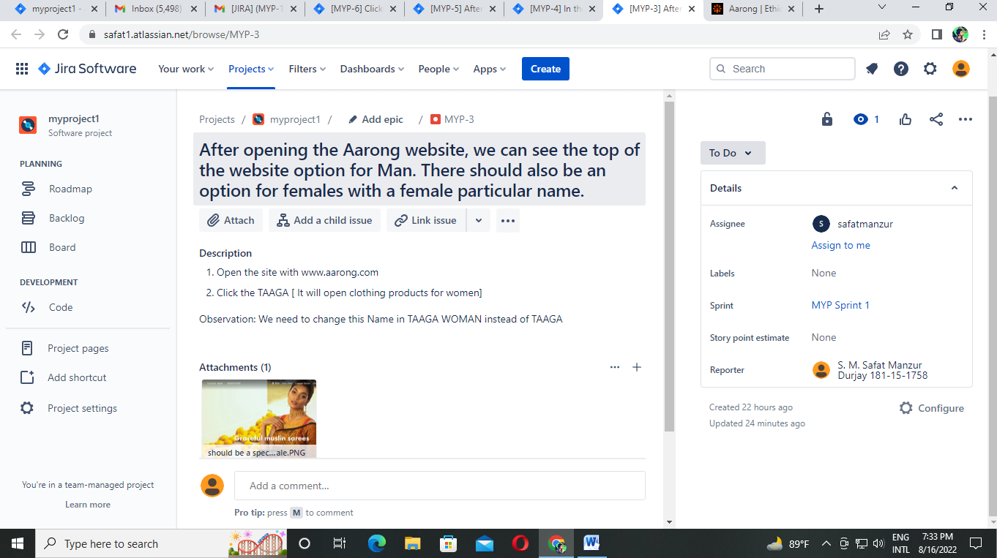

**Description:** The work is assigned to safatmanzur for solving the problem.

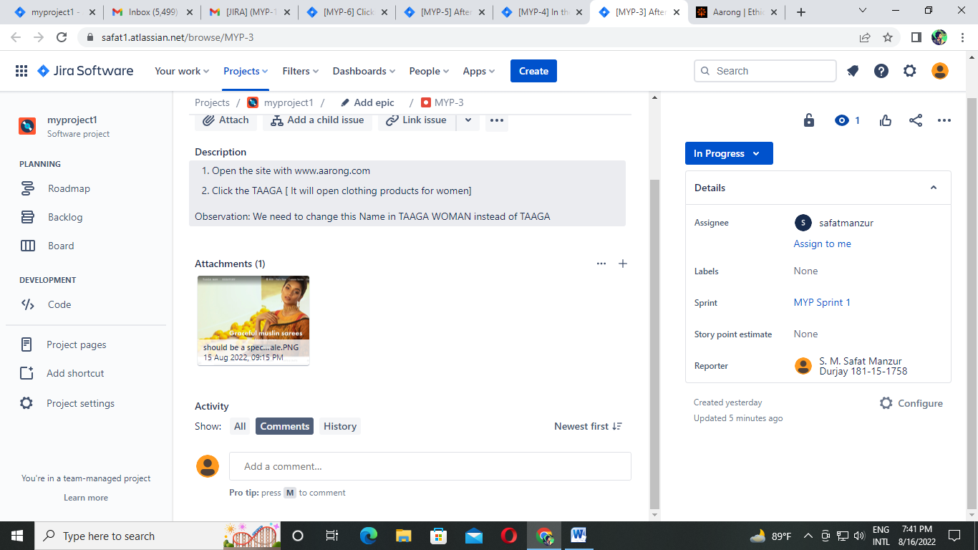

**Description:** The developer started working on it and it was in progress stage.

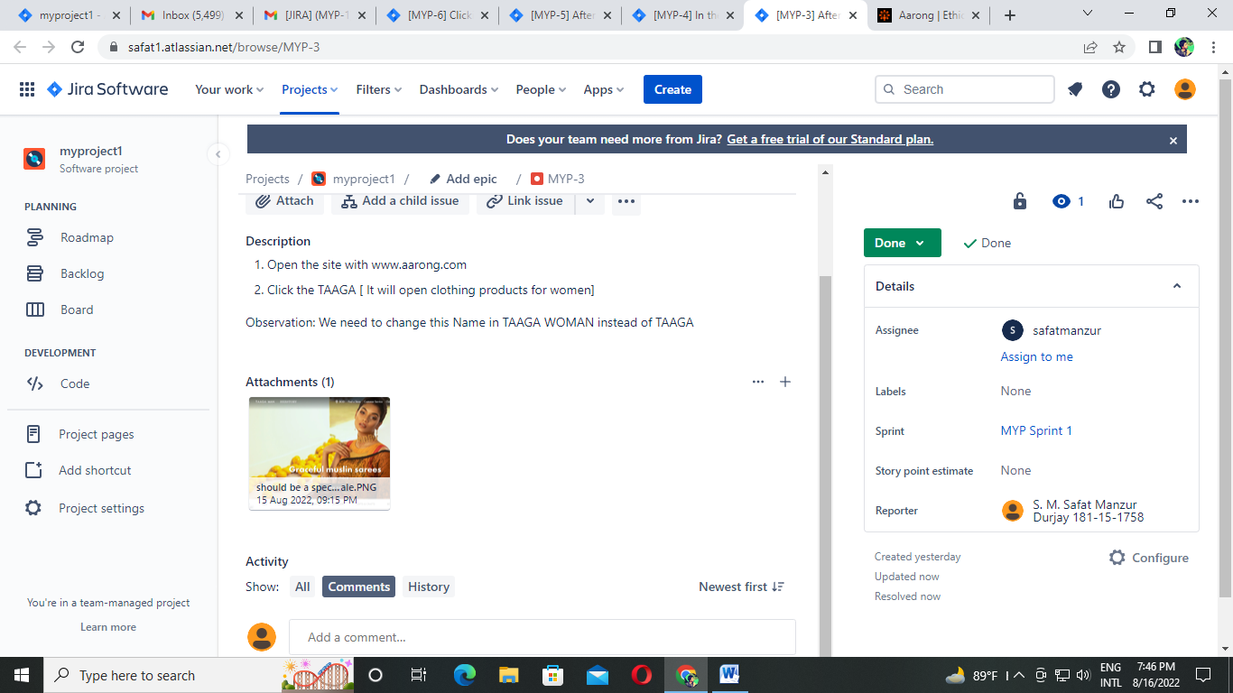

**Description:** The developer completed the work and the work has been done.

**Issue-02:** Accepting wrong name for Sign Up

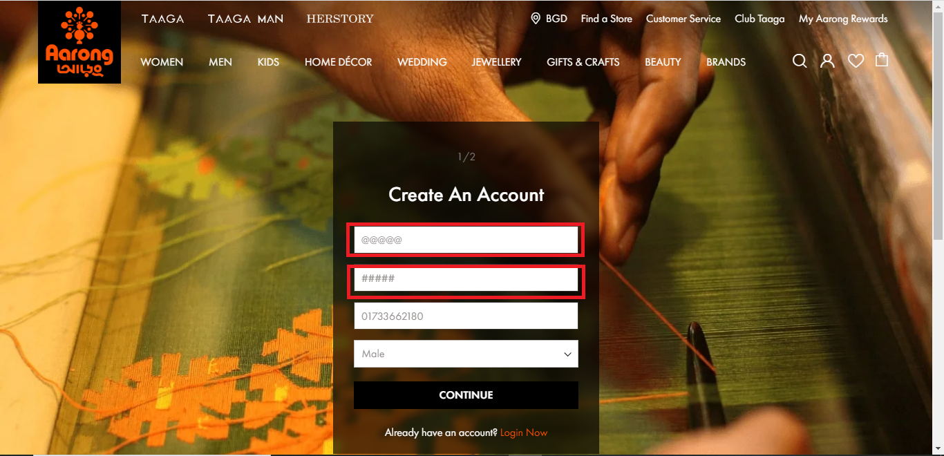

**Description:**

1. go to the site by searching [www.aarong.com](http://www.aarong.com)
2. After go the site you need to click on My Account
3. Then click on Sign Up Now
4. After fill up the name with special character and with valid phone number
5. The bug is in name, name cannot contain special character when we click on CONTINUE it should be said invalid name

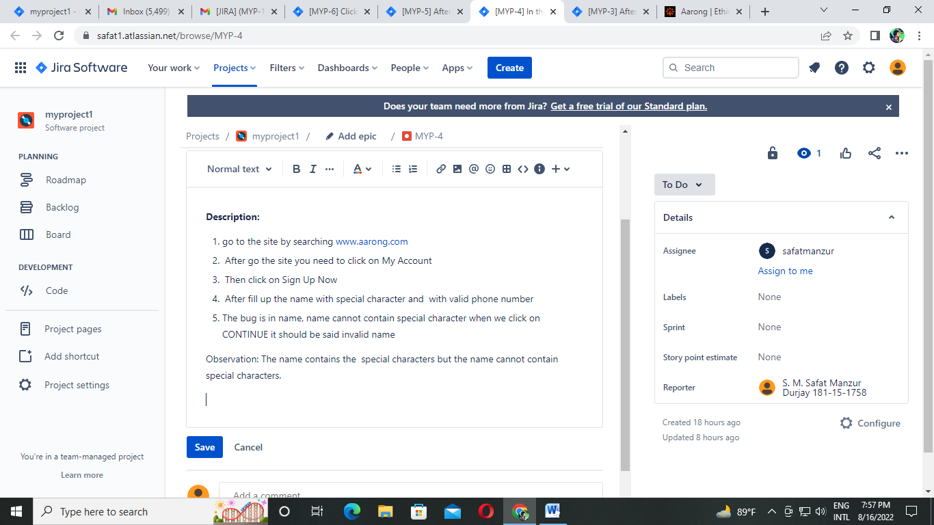

**Description:** The work is assigned to safatmanzur for solving the problem.

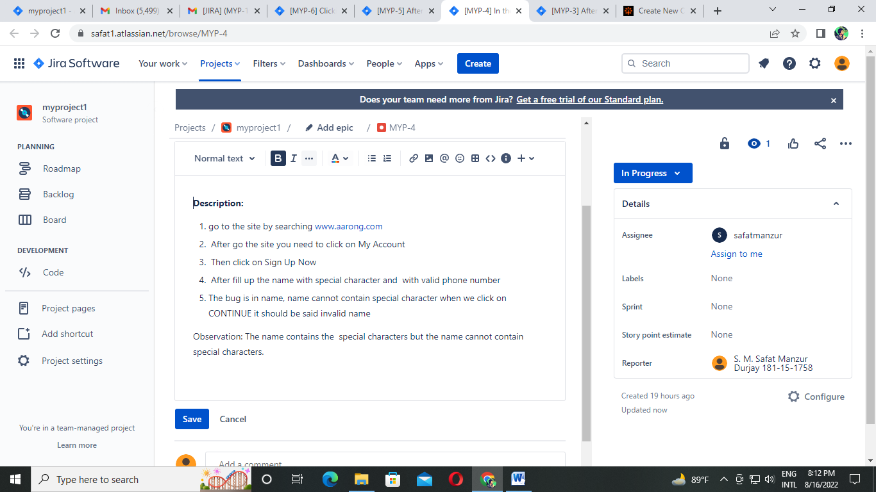

**Description:** The developer started working on it and it was in progress stage.

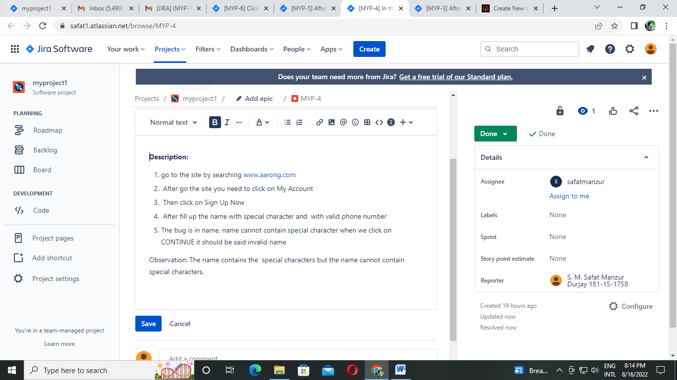

**Description:** The developer completed the work and the work has been done.

**Issue-03:** Created the account without showing a successful message

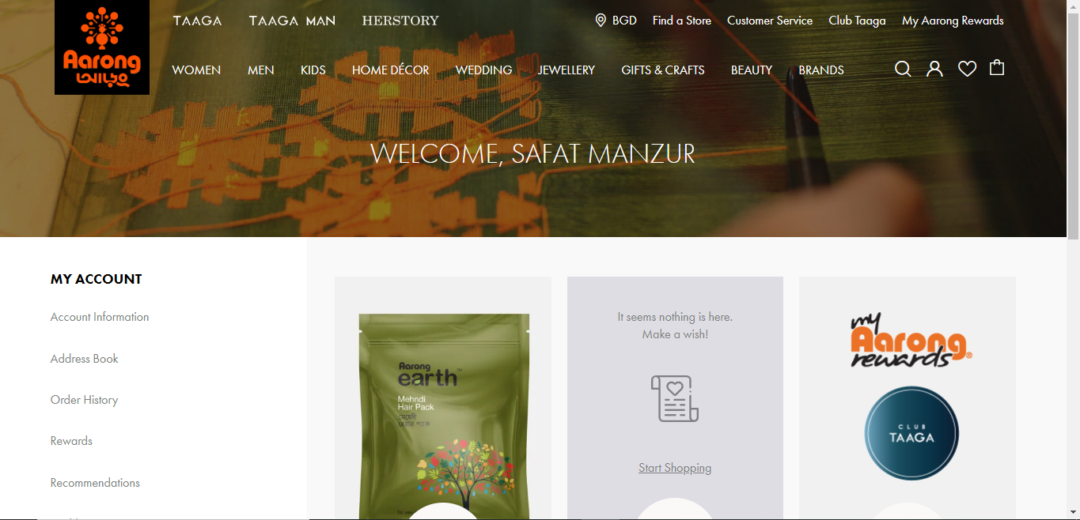

**Description:**

1. Go to URL www.aarong.com
2. Click on My Account
3. Click on Sign Up Now
4. Fill up the information correctly and click on CONTINUE
5. Again fill up the information and agree the condition then click on SUBMIT
6. After that account is created and a bug is found when creating the account and it is completed but successfully registration message is not shown then it should be called a bug.

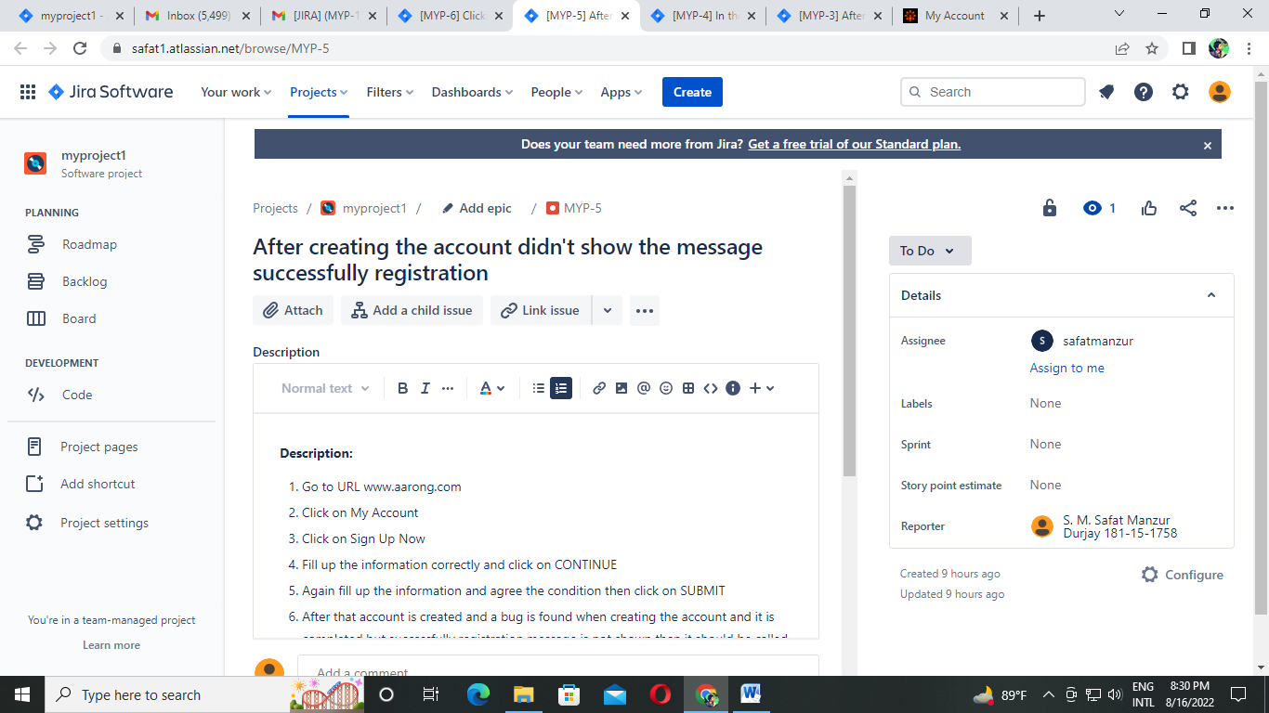

**Description:** The work is assigned to safatmanzur for solving the problem.

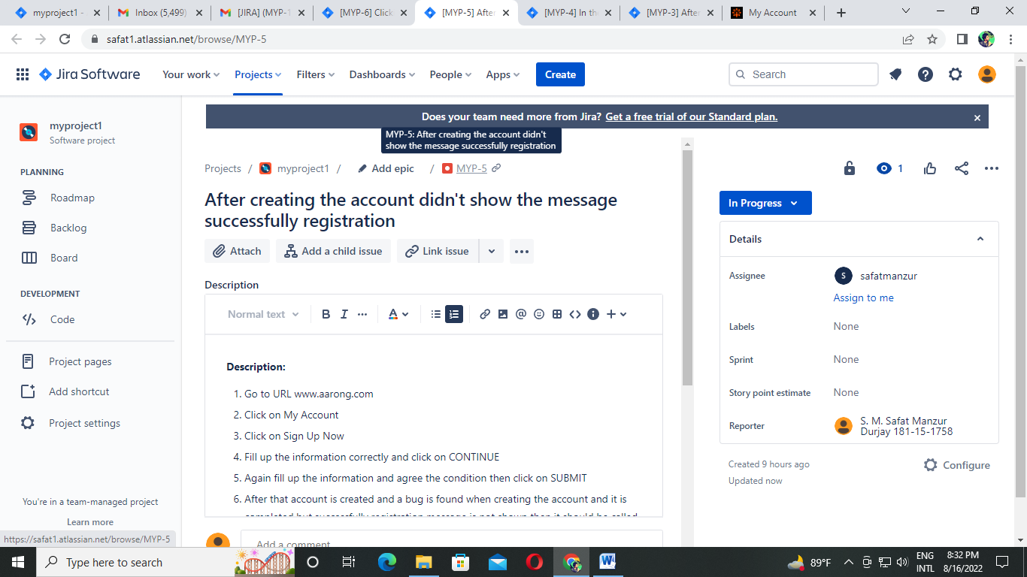

**Description:** The developer started working on it and it was in progress stage.

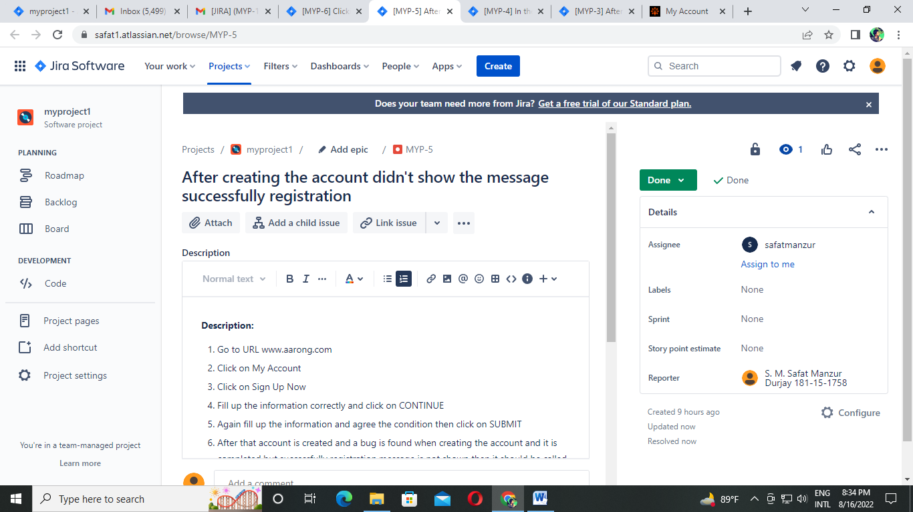

**Description:** The developer completed the work and the work has been done.

**Issue-04:** Facebook for Login didn’t work

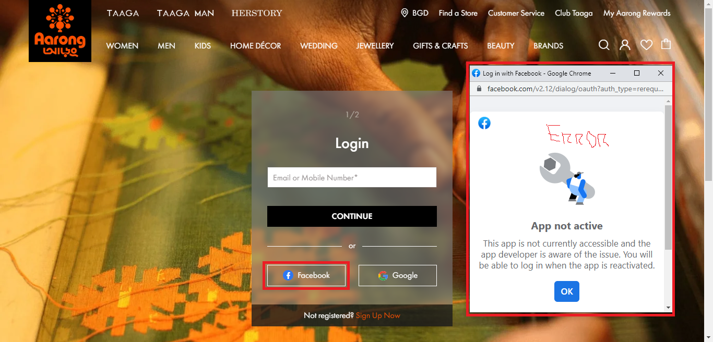

**Description:**

1. Go to URL www.aarong.com
2. Click on My Account
3. Click on Facebook icon for login
4. Bug is found here, the Facebook login option didn’t work but the icon is given.

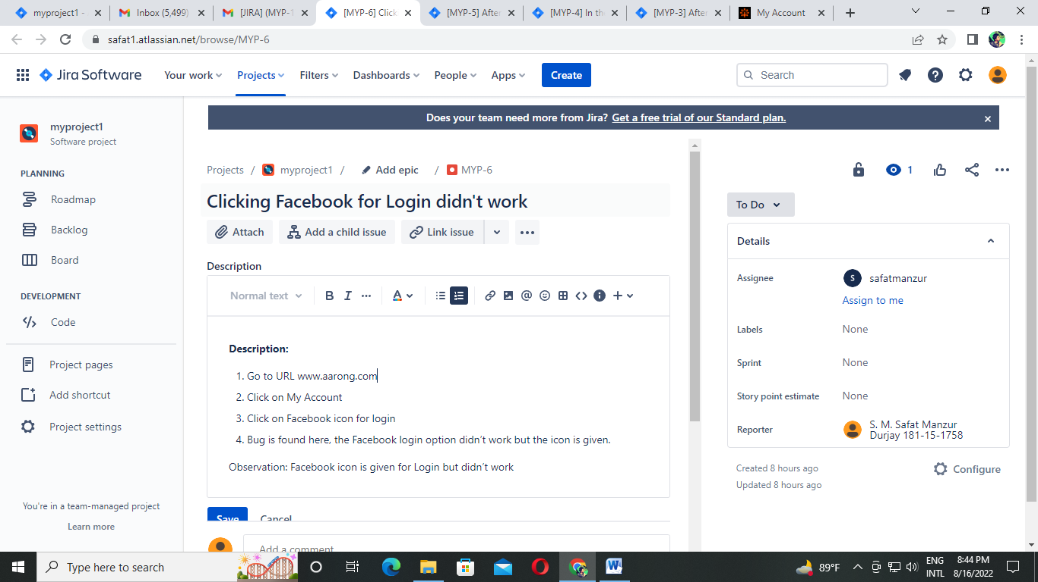

**Description:** The work is assigned to safatmanzur for solving the problem.

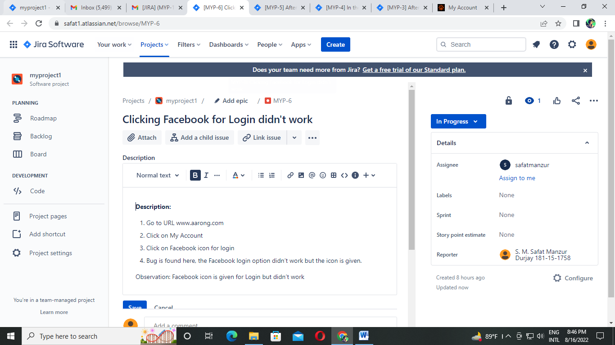

**Description:** The developer started working on it and it was in progress stage.

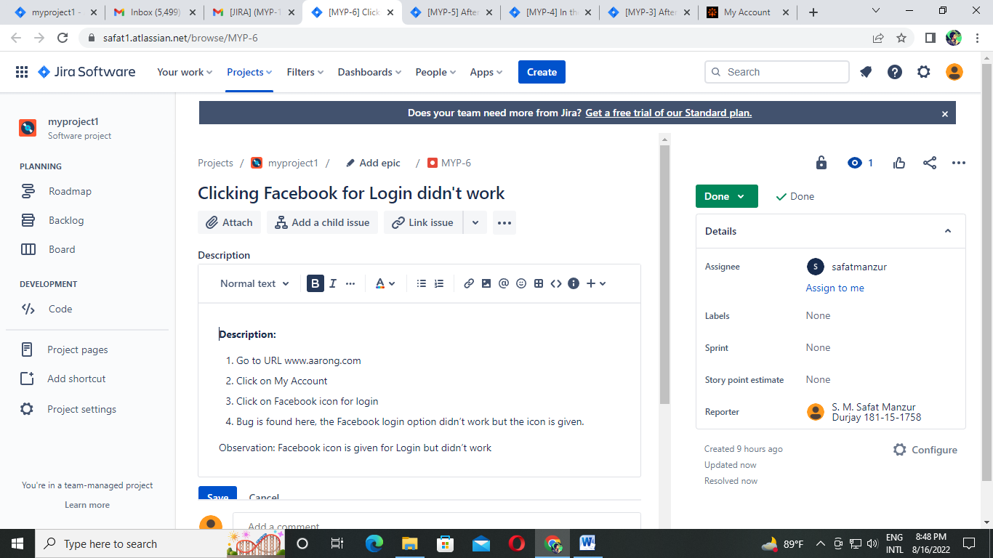

**Description:** The developer completed the work and the work has been done.